APP level 1- level 4 password : 123456789
APP level 5 password : 123456789abc

New version
Support :
10S -24S li-ion battery (30V-102V Lithium battery cell)
13S -24S lifePo4 battery (30V-88V Lithium iron phosphate battery cell)
15S -24S LTO battery (30V-68V Lithium titanate battery cell)

The default is the li-ion parameters. when you phone connect bluetooth , can click and set up lifePo4 / LTO parameters. default setting is 24S , if you use for other number of cells , change it in app .

Single cell voltage detection range 1V-4.6V. High precision detection cell voltage error is less than 5MA
Charging current 50A
Discharge current: 70A 100A 150A 200A 300A to choose
Balance current :200MA . Controlled balance mode, when the charging is started, the voltage difference can be detected by the detected voltage difference to be greater than the set value.
High-precision coulomb counter function temperature control detection Hall speed measurement

Bluetooth connection : support for android/iphone IOS phone
android have English/Russia language APP , iphone have Chinese app

Support cells :Support Li-ion , Lipo , 18650, Lifepo4 , LTO and so on

Voltage accuracy :Single cell voltage detection range (1.5-4.6V), so support a variety of cell use, accuracy error within 3 mV

Drop wire protection :detect wire not weld well and cause the voltage is wrong.balance wire drop cell protection

Overcharge protection: Connect to Bluetooth to set high-precision detection voltage, single overcharge protection and total voltage overvoltage protection

Over discharge protection : Connect Bluetooth to set up high-precision detection voltage, single-cell over-discharge protection and total voltage under-voltage protection

Short circuit protection: Can be connected to Bluetooth to set the short circuit protection value, change to 0 is turn off short circuit protection

Overcurrent protection: can be connected to Bluetooth to set up the overcurrent protection value (maximum 300A)

Current detection: within the current range of the purchased protection board

Temperature control protection: The protection board has built-in balanced temperature control, power temperature, and can be connected with 4 temperature controls to prevent high temperature danger.

balance current: 200 mA, high voltage versus low voltage discharge balance

Discharge current: refer to the current in the purchase selection as the peak discharge current

Charging current: less than 50A

Coulomb counter: compensation 1-24S battery connection between the chip resistance is too long, causing the wire resistance to be too large, the cell voltage is too large during the charging and discharging, can not be used normally

Connection internal resistance: based on current to time scoring, accurately calculate the remaining battery capacity and charging current
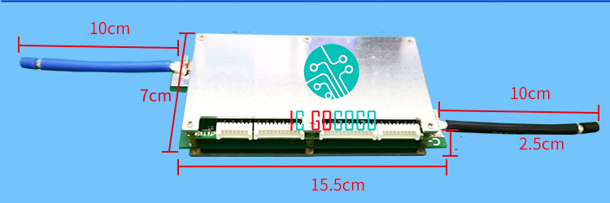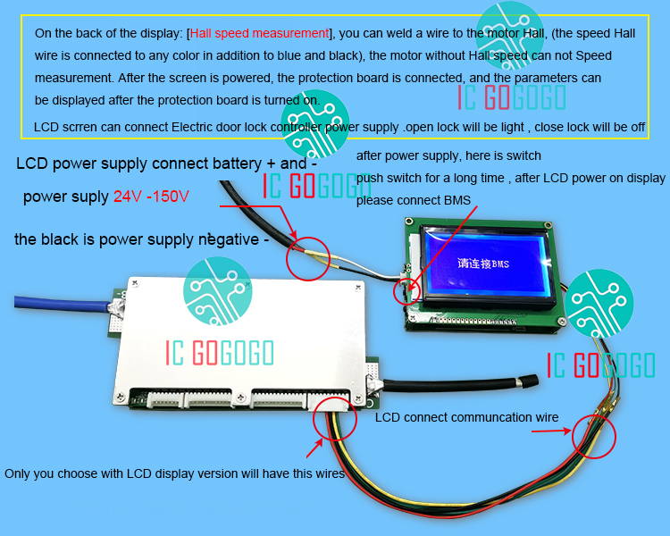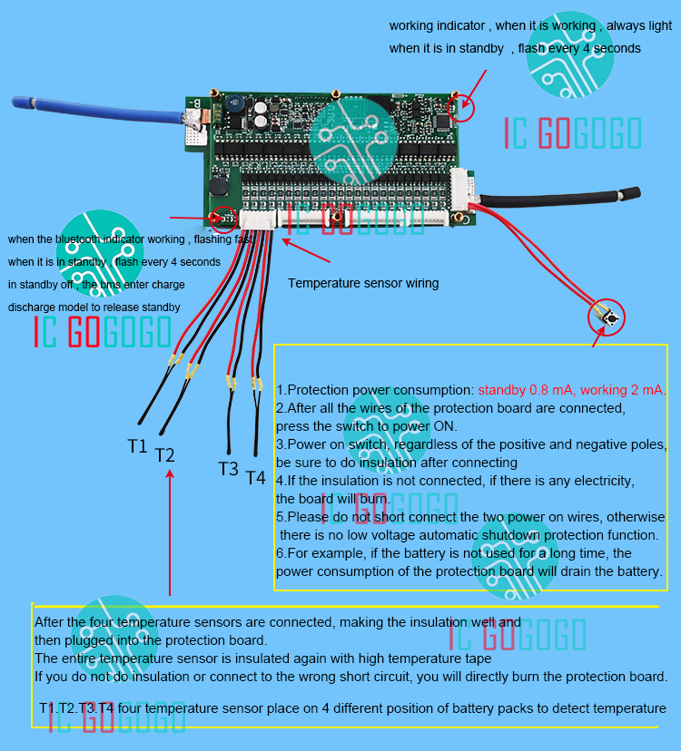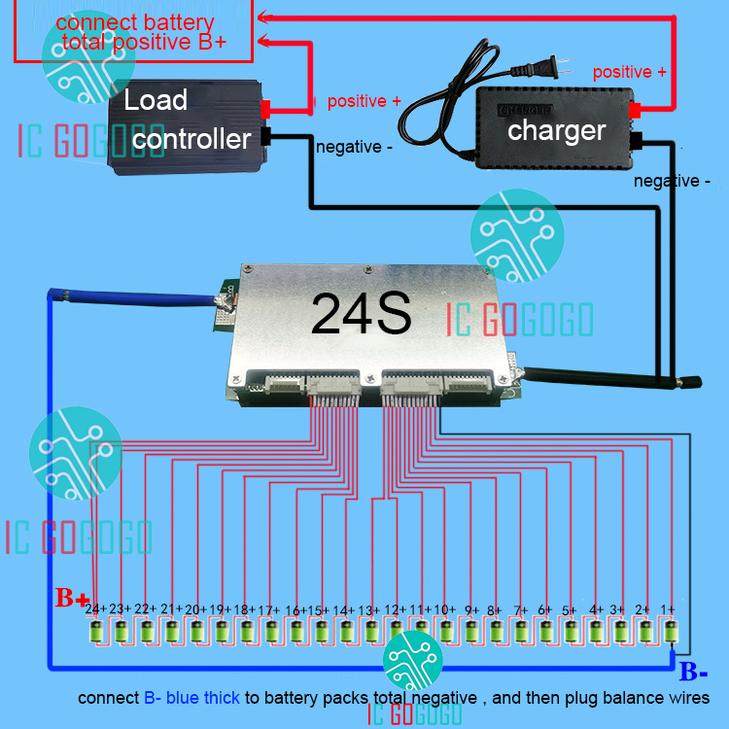
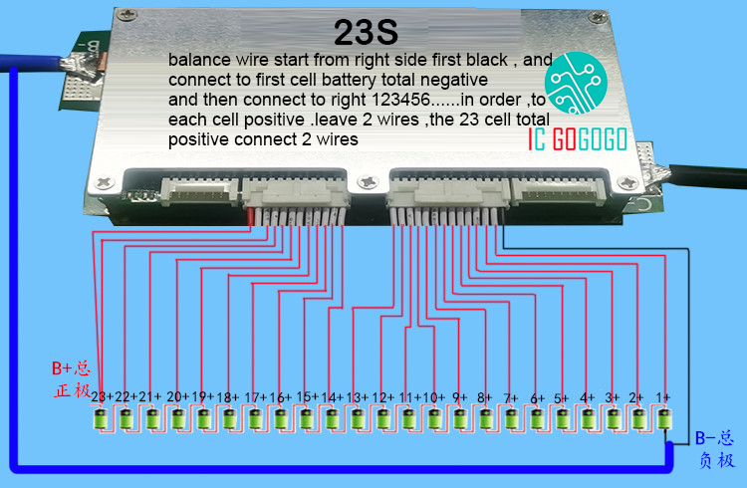
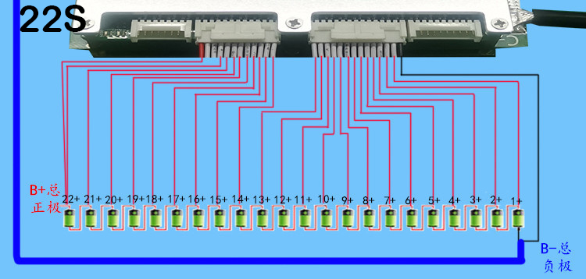
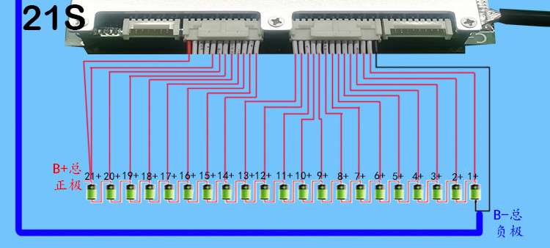
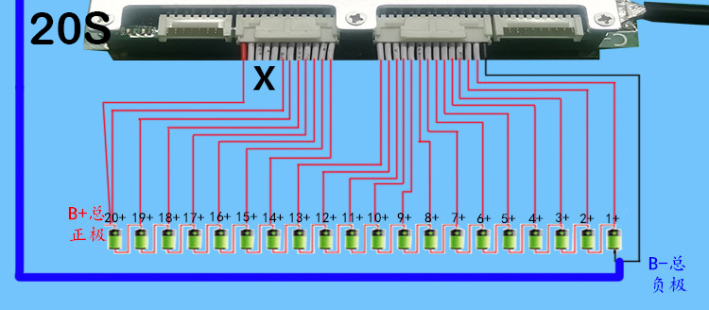
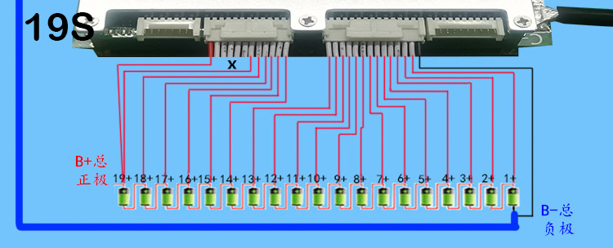
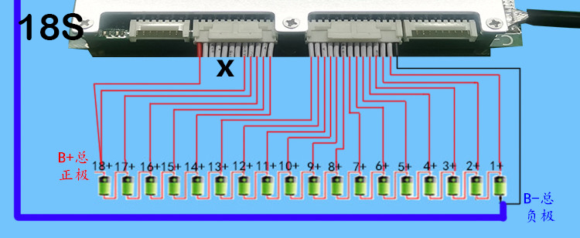
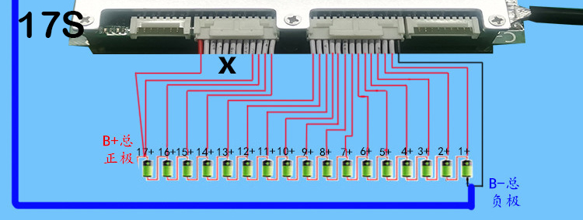
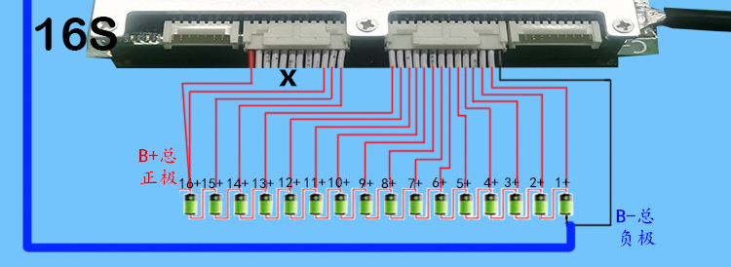
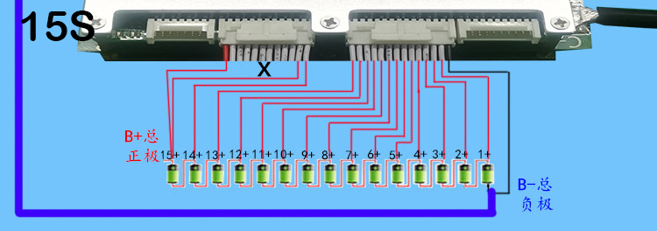
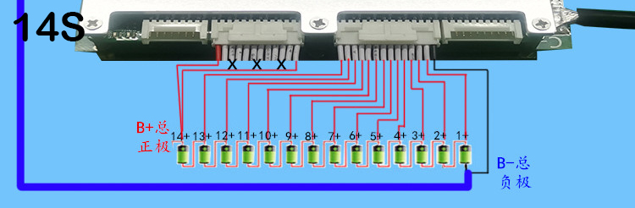
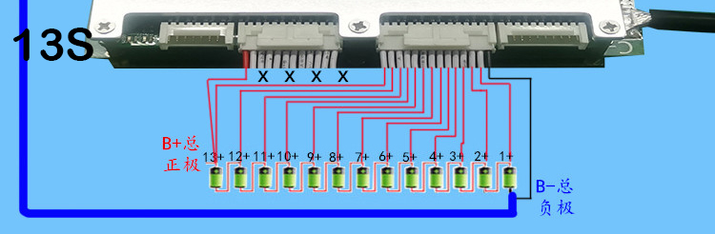
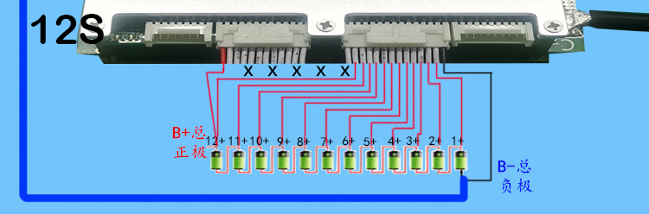
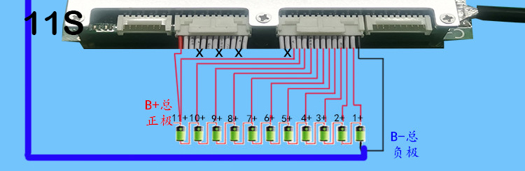

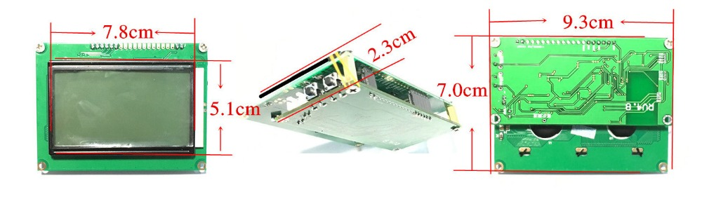

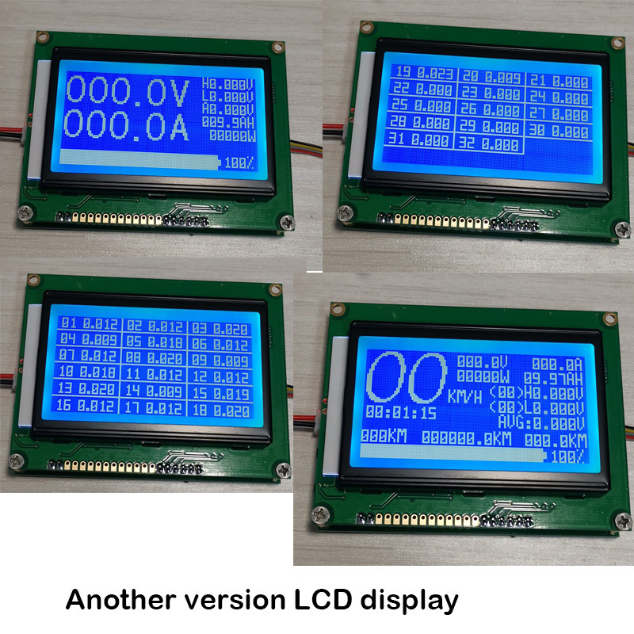

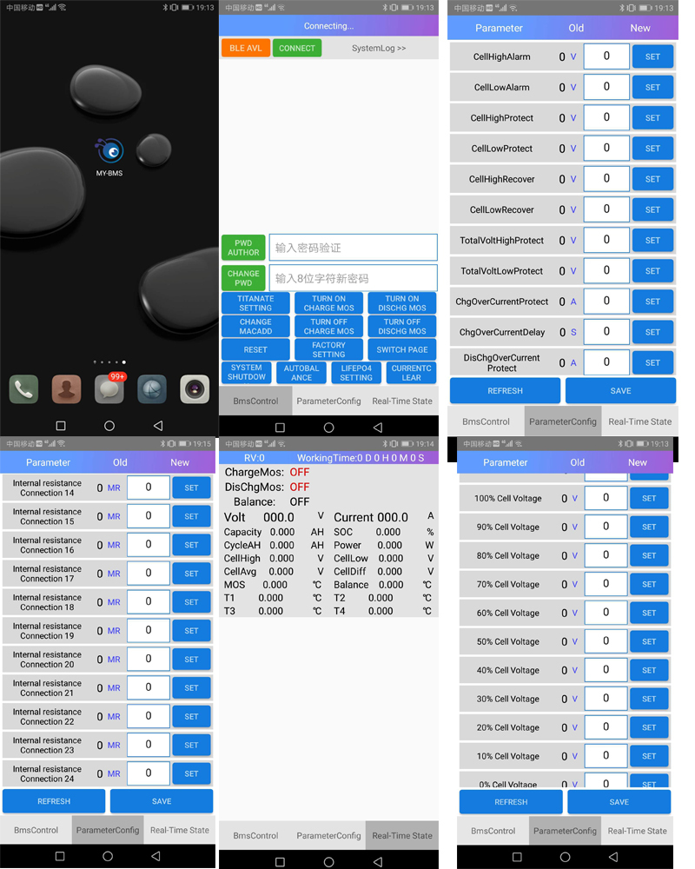
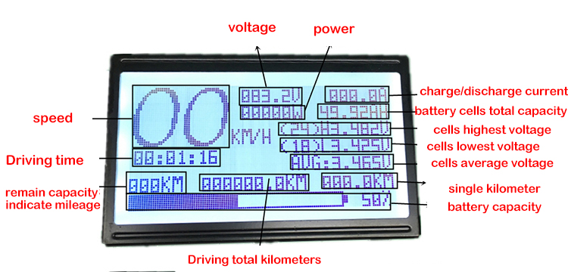
About starting and closing buttons:
1. If the protection board is turned off due to abnormal power failure, only a short press button is needed to start the normal operation of the BMS.
2. During the normal operation of the protection board, press and hold this button for more than 5 seconds, then release the button, the protection board will automatically turn off the power, stop working, zero power consumption, short press can realize the display of the matching screen of the switching protection board.
3. Protection board If the discharge tube is not turned on for more than 5 minutes, the protection board will automatically turn off the main power, stop working, and consume zero power.
4. If the BMS power supply is turned off for the reasons of the second and third conditions, press the power button for 3 seconds to start the normal operation of the protection board.
5. If a matching display is connected, short press this button to switch the screen display.
6. Power button Please ensure good insulation, otherwise it may not be able to automatically turn off the BMS power supply.

About onboard Bluetooth;
Bluetooth is turned on only when the mainboard is not in standby status. After 3 minutes the board is power on, board no current will enter standby status and Bluetooth will be turned off. Having the discharge or charging current , the system will cancel the standby status and Bluetooth will be turned on. You can observe the power led lights on both sides of the protection board. If they are always on, you can connect Bluetooth. If the system is standby, you can short press the protection board start button to activate Bluetooth once. Or re-start the protection board to activate Bluetooth. Make sure Bluetooth is turned on. In the phone's system settings Bluetooth settings, search for Bluetooth devices. Search once without searching. Please search multiple times. The name (BMS_ANT) sometimes shows null, click the pairing password 1234. Open the APP you download and click Connect the device, select the device you just paired to connect
Protection board calibration:
1. Single cell voltage calibration: You can adjust the "system reference voltage" (the default is about 3.0) to slowly increase the size of 0.001, turn down, you can change the unit voltage value until accurate!
2. Total pressure calibration: You can adjust the "total pressure calibration parameter" (the default is about 3330), slowly adjust the size of this value, you can change the total pressure until accurate!
3. Current calibration: You can adjust the "current sensor range", slowly adjust the size of this value, you can change the current until accurate!
Note: Do not change the “Power Start Current” item in the parameter setting. If it is too large, it may result in burning and discharging the MOS transistor! ! !

About the automatic balance function:
The auto-balance function is mainly a function that sets the battery's difference too much. Users must use it when the battery is fully charged or nearly fully charged. When the battery is fully charged, unplug the charger and click " Auto balance, at this time, the protection board will automatically balance until the battery pack voltagge difference is less than 0.001, or the user clicks on "automatic balance" again to turn off, whether the automatic balance is turned on or off can switch the screen to "system state" to view "balance "Status. If "Auto balance " is displayed, it means that the automatic balance is in progress!
About balance : The protection board balance is automatically controlled by the program through the configured balance parameters, where "balance limit voltage" is interpreted: when any cell voltage detected in the system exceeds the configured “balance limit voltage”, the system exceeds the balance limit voltage. All the cells are discharged and balance ; "Balance Control Voltage" "balance Pressure voltage Difference" explains: These two parameters are the parameters for controlling the battery charging when the battery is charged, the cell voltage is higher than the balance control voltage, and the highest The lowest voltage difference is greater than the balance voltage difference, and the charging current is less than 15A, the charging voltage difference will be started. If the charging current is greater than 15A, the system will start the charging differential balance after the charging overvoltage protection. If the battery is fully charged, placed at rest, and the voltage difference is greater than the set value, the system will automatically start static balance

Old version :
Support :
7S -24S li-ion battery (24V-102V Lithium battery cell)
8S -24S lifePo4 battery (24V-88V Lithium iron phosphate battery cell)
10S -24S LTO battery (24V-68V Lithium titanate battery cell)

The default is the li-ion parameters. when you phone connect bluetooth , can click and set up lifePo4 / LTO parameters

Single cell voltage detection range 1V-4.6V. High precision detection cell voltage error is less than 5MA
Charging current 50A
Discharge current: 70A 100A 150A 200A 300A to choose
Balance current :200MA . Controlled equalization mode, when the charging is started, the pressure difference can be detected by the detected pressure difference to be greater than the set value.
High-precision coulomb counter function temperature control detection Hall speed measurement
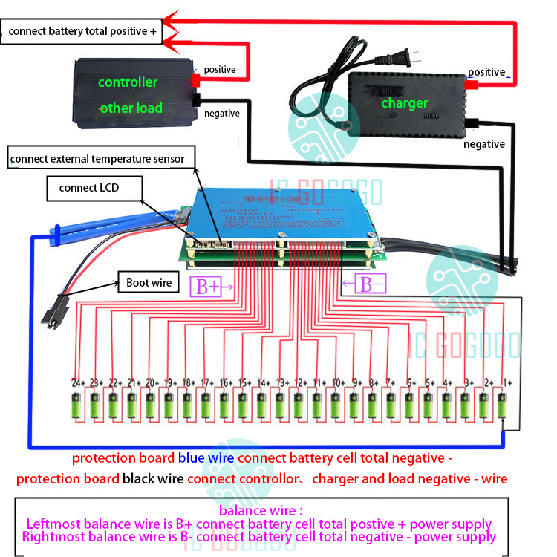
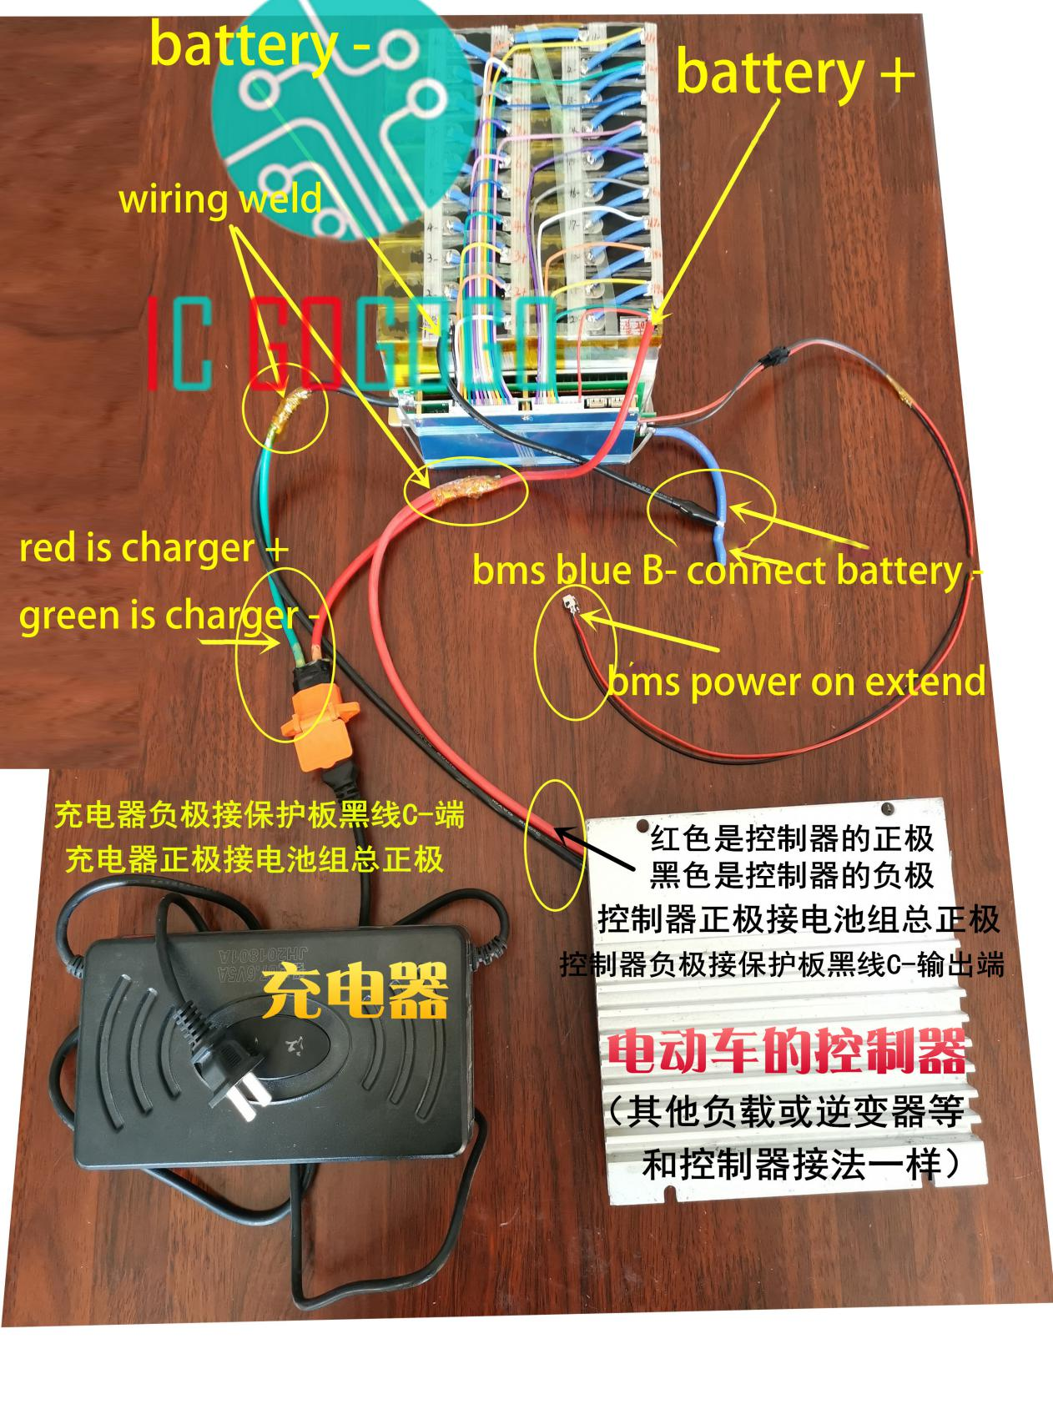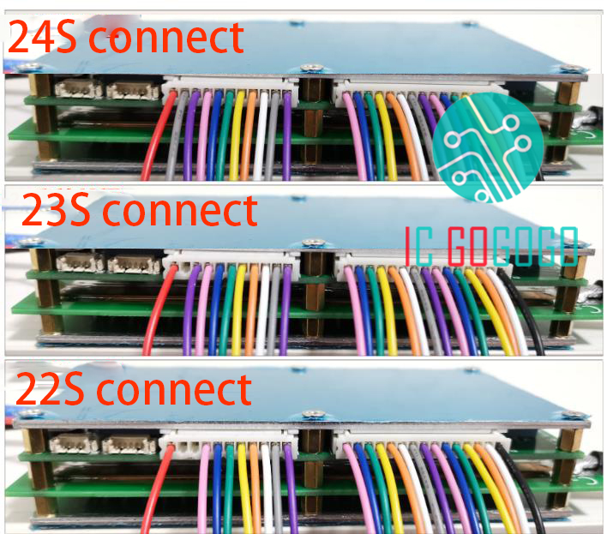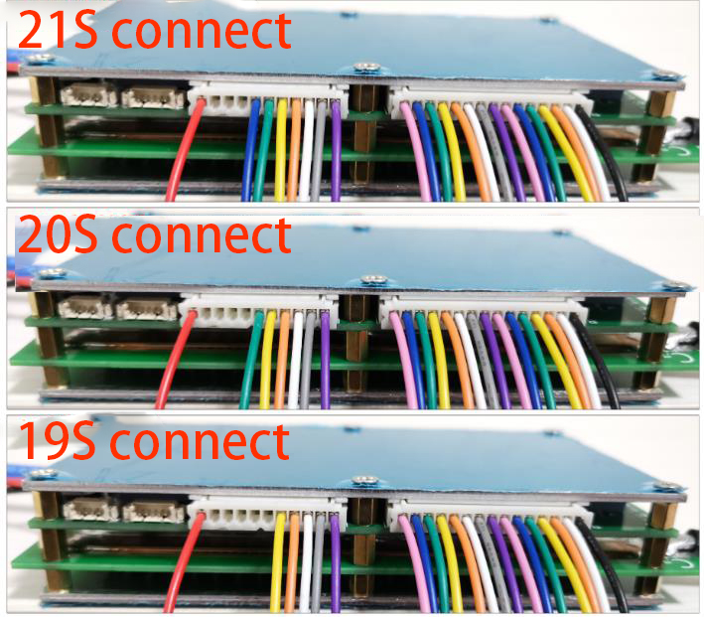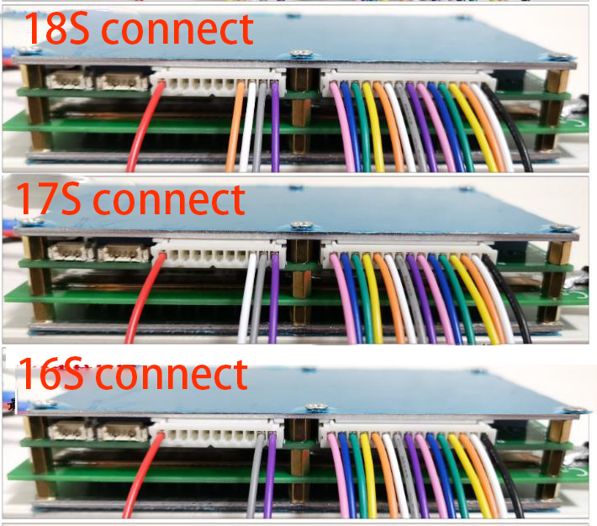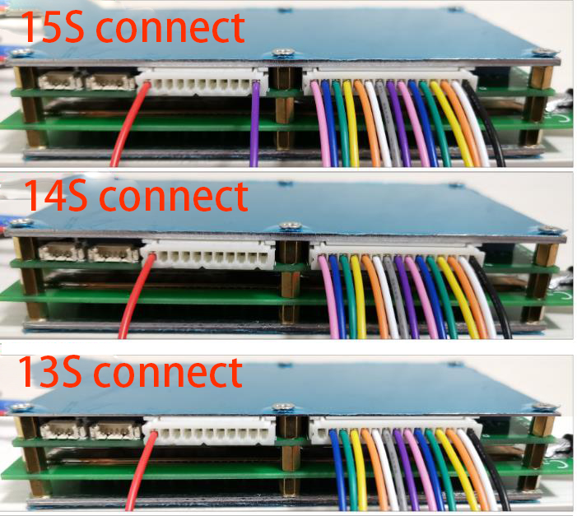
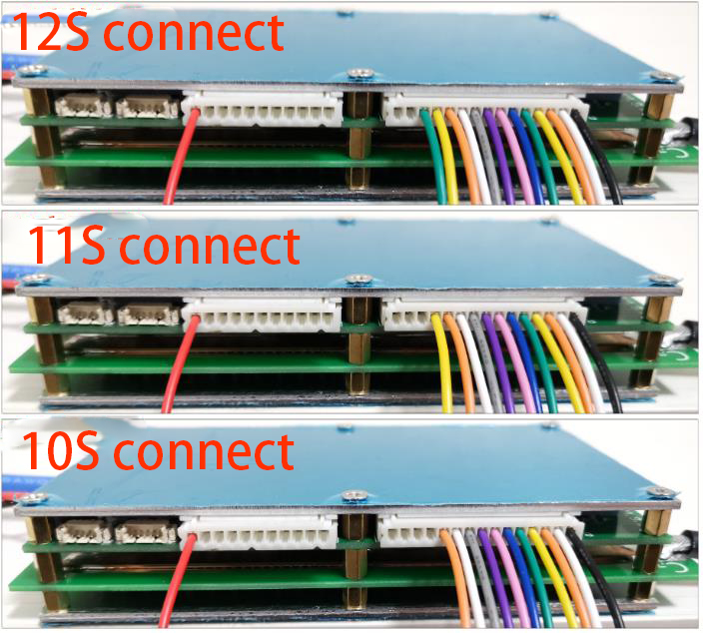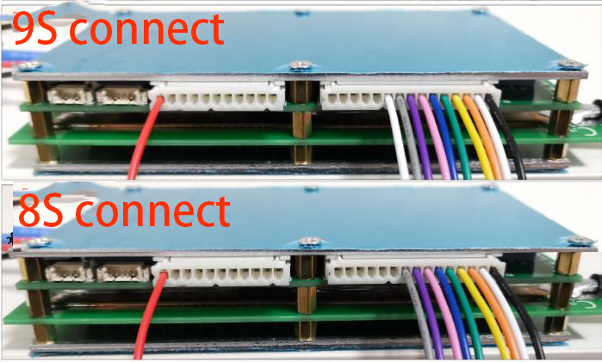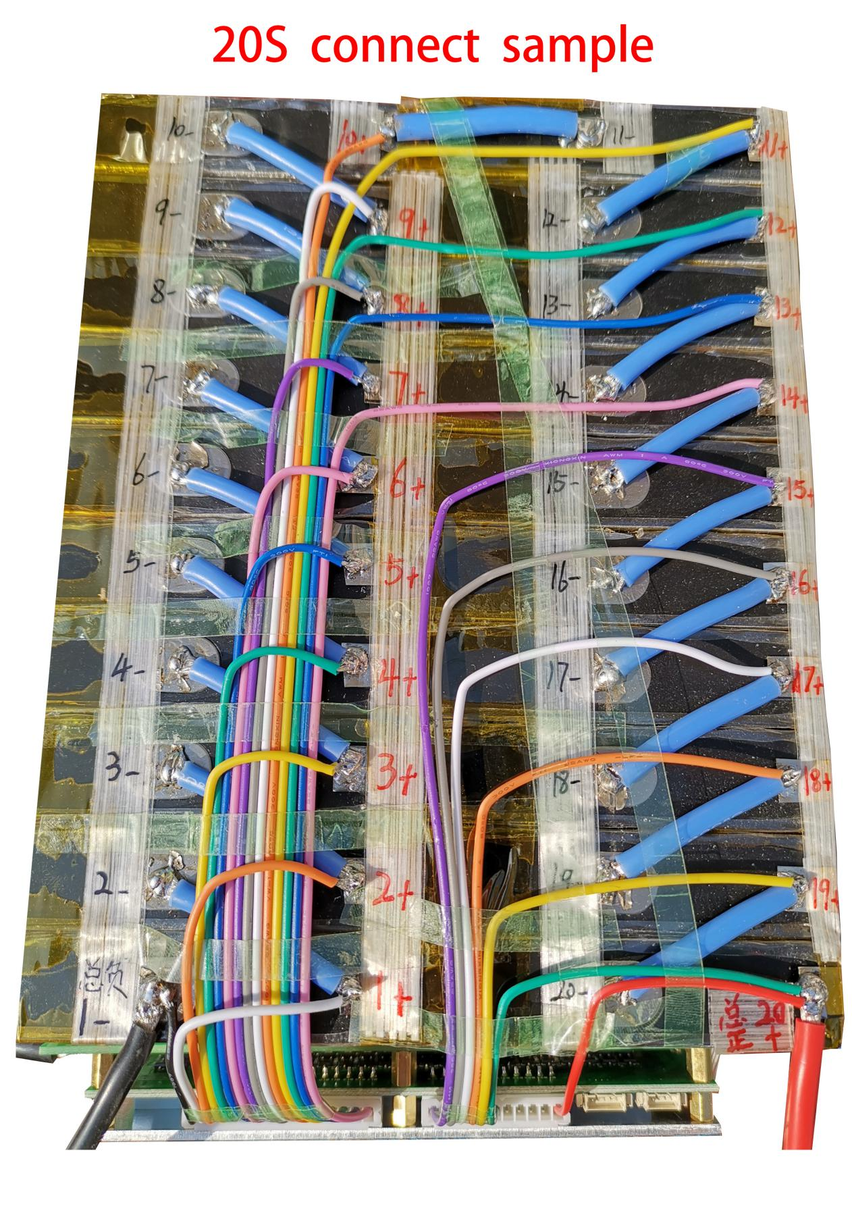

The balance wire connects the positive electrode + of the battery pack from the right to the left
1+ is the location of the first cell wire
2+ is the location of the second cell wire
If battery cell is not full enough 24S, ignore it
After connecting the wires, connect Bluetooth to set the battery parameters and the number of cells to use

temperature sensor connect :

include 4 temperature sensors and one 5P cord plug ( it don't have effect if you don't connect temperature sensors )
Picture ① Use scissors to cut the temperature sensor a bit
As shown② find two thin wires welded to the temperature sensor
③④ Put into the heat-shrinkable tube on the position where the four temperature sensors are welded.
⑤5P black wire is connected to one of the four temperature sensors wire , and the other four red wire match each temperature sensors .
Note : 5P wire is the common wire , and the other 4 wires are the T1 T2 T3 T4.
The 4 position temperature can be displayed on the mobile phone . don't have difference between - and +
As shown ⑥, the temperature sensor must be insulated with a high temperature tape
Finally put the battery in 4 different locations, detect the temperature of the battery 4 locations
External temperature sensor can be connected to a maximum of 4 pieces， you can also connnect 1 pcs or 2 pcs or 3 pcs

